Department of Electrical and Computer Engineering

ECE 363 Communications Networks
Lab 1

Name  Student no.  Date  Lab Title  Lab Section | Arfaz Hossain  V00984826  February 8, 2024  Introduction to WireShark and Layered Protocol  B03

Discussion
In this lab, students are tasked with familiarizing themselves with Wireshark, a widely used network protocol analyzer. Wireshark passively observes packets transmitted to or from a designated network interface, providing insights into network traffic without actively participating. It captures copies of packets exchanged by applications and protocols running on end systems, enabling analysis of various network activities. Through this exploration, students gained practical experience in examining network protocols and understanding their layered structure. The lab exercises helped students gain more knowledge into capturing traces, identifying protocols, calculating overhead, examining packet headers, and utilizing networking tools such as "ifconfig", "ping", and "netstat" to solidifying their understanding of network operations.

Procedure
This lab introduced students to Wireshark, covering the installation process, getting acquainted with the tool, and analyzing layered protocols, especially focusing on HTTP GET packets. It provided practical insights into network packet capture and analysis. Students learned to draw the structure of an HTTP GET packet and performed calculations related to packet overhead through looking at all the byte positions in the captured packet data and calculating the sizes of each packet in the capture. Students used Wireshark's capture filters to refine packet capturing through employing the filter tcp port 80 to capture relevant packets for their analysis using wget command while excluding unrelated network traffic. On the Layered Protocol analysis, students examine detailed information regarding different layers of the protocol in HTTP GET packets, using both provided and captured packets for analysis. The lab also encouraged exploration of networking tools like ifconfig ping and netstat to enhance understanding of computer networking concepts.

Please Turn Over

1.3.1 Running WireShark

1.3.1.1 Capture a trace without any filters.

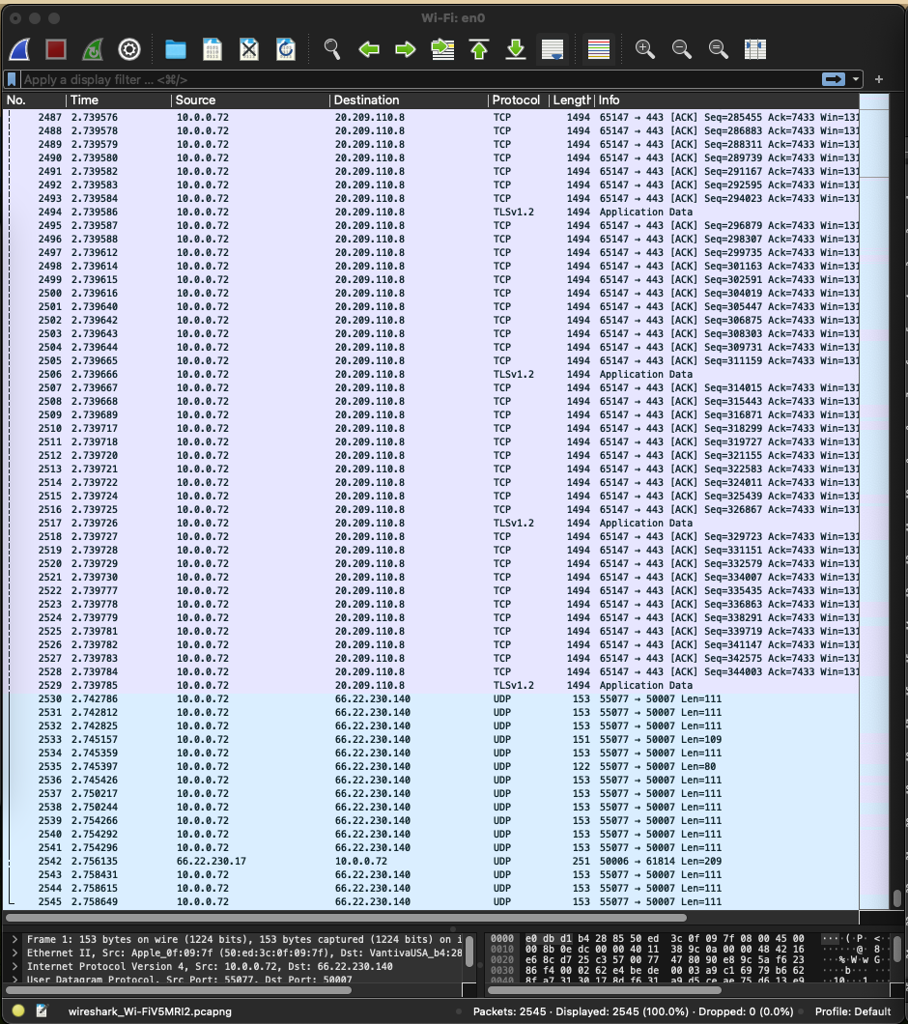

One trace without any filters:

Time Source Destination Protocol
2.791961 2604:3d08:2481:4f00:18a1:72ab:c591:ca53 2603:1063:2200:30::42 TCP

Length Info
74 63756 → 443 [ACK] Seq=1 Ack=34 Win=4095 Len=0

1.3.1.2 List at least 3 different protocols that appear in the protocol column of the unfiltered packet-listing window.

I got 3 different protocols which appeared in the protocol column of the unfiltered packet-listing window. These protocols represent different layers and functionalities within network communications. These are: TCP, UDP and

TCP (Transmission Control Protocol): TCP is a connection-oriented protocol used for reliable, ordered, and error-checked delivery of data packets over a network. It is widely used for applications such as web browsing, email, file transfer, and more.¹

Time Source Destination Protocol
2.791961 2604:3d08:2481:4f00:18a1:72ab:c591:ca53 2603:1063:2200:30::42 TCP

Length Info
74 63756 → 443 [ACK] Seq=1 Ack=34 Win=4095 Len=0

UDP (User Datagram Protocol): UDP is a connectionless protocol that offers a minimal amount of service when messages are exchanged between computers in a network that uses the Internet Protocol (IP). UDP is commonly used in applications where speed is more critical than reliability, such as real-time communication protocols, online gaming, and streaming media.²

Time Source Destination Protocol Length Info
2.584709 10.0.0.122 10.0.0.255 UDP 305 58739 → 54915
Len=263

TLSv1.2 (Transport Layer Security version 1.2): TLS is a cryptographic protocol used to establish a secure communications channel between two systems. TLSv1.2 is a version of TLS and represents one of the iterations of the protocol. It provides privacy and data integrity between communicating applications and is commonly used in securing web communications, email transmission, and other forms of data exchange over networks.³
Time Source Destination Protocol
1.693690 2620:1ec:8f8::10 2604:3d08:2481:4f00:18a1:72ab:c591:ca53 TLSv1.2

Length Info
125 Change Cipher Spec, Encrypted Handshake Message

Please Turn Over

1.3.1.3 How long did it take from the HTTP GET message being sent to the
HTTP OK reply being received?

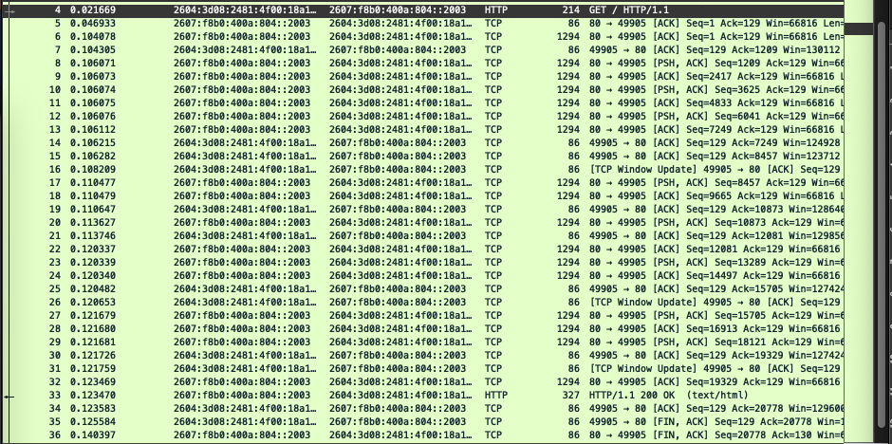

(0.123478 seconds – 0.021669 seconds) = 0.101809 seconds

1.3.2 Layered Protocol

1.3.2.1. Draw the structure of an HTTP GET packet.

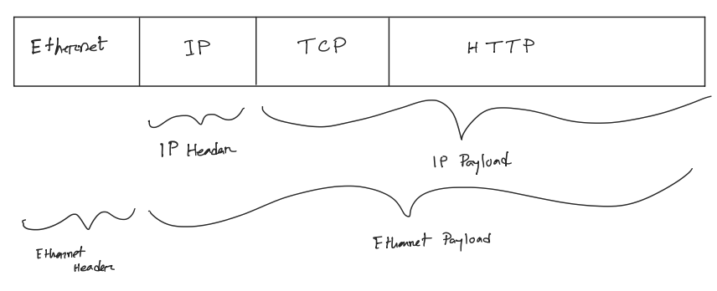

In a packet structure of an HTTP GET request, we first encase the data within a TCP header. This TCP packet is then wrapped within an IP packet by adding an IP header. This IP packet is finally inserted into an Ethernet frame, which adds the Ethernet header and footer.
The packet structure of an HTTP GET request contains three key components that are layered or nested within each other: Ethernet, IP, and TCP. Considering the overall packet as a long, thin rectangle, and going from left to right (since leftmost elements being the first sent on the wire), we start with the Ethernet Header. The Ethernet header typically has 14 bytes, so I marked it on the first section of my rectangle. The remaining part of this layer is considered the Ethernet payload, which is the data that IP passed to Ethernet over the network.
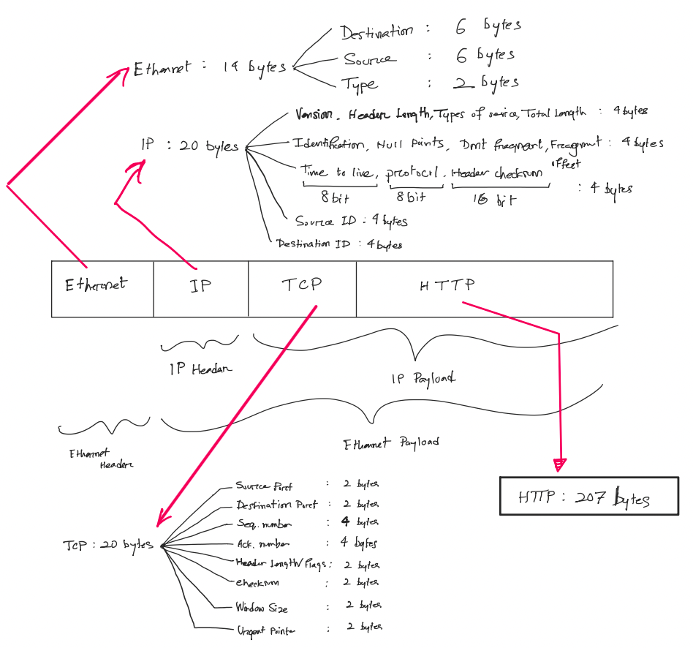

Within the Ethernet payload, we can find both the IP header, and the IP payload. The IP header, depending on whether it's IPv4 or IPv6, will either have 20 bytes (IPv4) or 40 bytes (IPv6). The remaining part of the IP payload is the TCP Header, which can vary in size but typically is 20 bytes unless options are being used. The rest of the TCP segment encompasses the actual HTTP GET request.
1.3.2.2. In the provided trace (lab1-wget-trace.pacp), calculate the average overhead of all of the packets from the server to the client (in percentage). (Hint: For a packet, the overhead is the size of all headers over the packet's total size. The average overhead is the ratio of the sum of the headers' size over the sum of the packets' size).

Header Length: ﻿2$×$40+ 26$×$20 + 24$×$32 = 1368
Packet Length: (﻿2$×$74) + (13$×$66) + (7$×$1484) + 177 + 1362 + 164 + 216 = 13313
Overhead: $({ 1368}/{13313} )=0.1028$

1.3.2.3. Which bytes in the Ethernet header field tell that the next higher layer protocol is IP? What is its hexadecimal value?

Each of the Ethernet Header field has 14 bytes of data, and the last 2 bytes of this field has 2 bytes allocated for specifying the “type” for the next higher layer. Bytes 13 and 14 points the next layer (Internet Protocol, IP), and their hexadecimal value is 0x0800.

1.3.2.4. Which bytes in the IP header field tell that the next higher layer protocol is TCP? What is its hexadecimal value?

Each of the Internet Protocol/ IP Header field has 20 bytes of data, and the last 10th byte of the field has one byte allocated for specifying the “protocol” for the next higher layer. The 10th byte points the next layer (TCP layer), and their hexadecimal value is 6.

1.3.3 Networking Tools

Explore the usage of \ifcon g", \ping", \netstat", and answer the following questions. (Hint: If you are not sure about how to use these commands, please refer to \Sec. 1.1.3 Networking Tools".)

1. How many Ethernet interfaces are in your computer, and how to determine it?

To find the number of Ethernet interfaces on the computer, the 'ifconfig' command proves instrumental, offering a comprehensive overview of network interfaces. Specifically, the command ifconfig -a provides detailed information about all available interfaces. By utilizing a refined command like ifconfig | grep -E '^en\d*:' | grep -v 'lo0' one can filter out irrelevant details and focus solely on Ethernet interfaces.

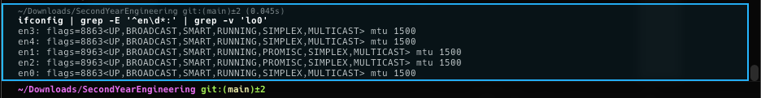

The provided code snippet, generated by the refined command, reveals the presence of multiple Ethernet interfaces:

- en3: flags=8863<UP,BROADCAST,SMART,RUNNING,SIMPLEX,MULTICAST> mtu 1500
- en4: flags=8863<UP,BROADCAST,SMART,RUNNING,SIMPLEX,MULTICAST> mtu 1500
- en1: flags=8963<UP,BROADCAST,SMART,RUNNING,PROMISC,SIMPLEX,MULTICAST> mtu 1500
- en2: flags=8963<UP,BROADCAST,SMART,RUNNING,PROMISC,SIMPLEX,MULTICAST> mtu 1500
- en0: flags=8863<UP,BROADCAST,SMART,RUNNING,SIMPLEX,MULTICAST> mtu 1500

There are five distinct Ethernet interfaces on the computer, namely en0, en1, en2, en3 and en4.

(actual iconfig -a output)

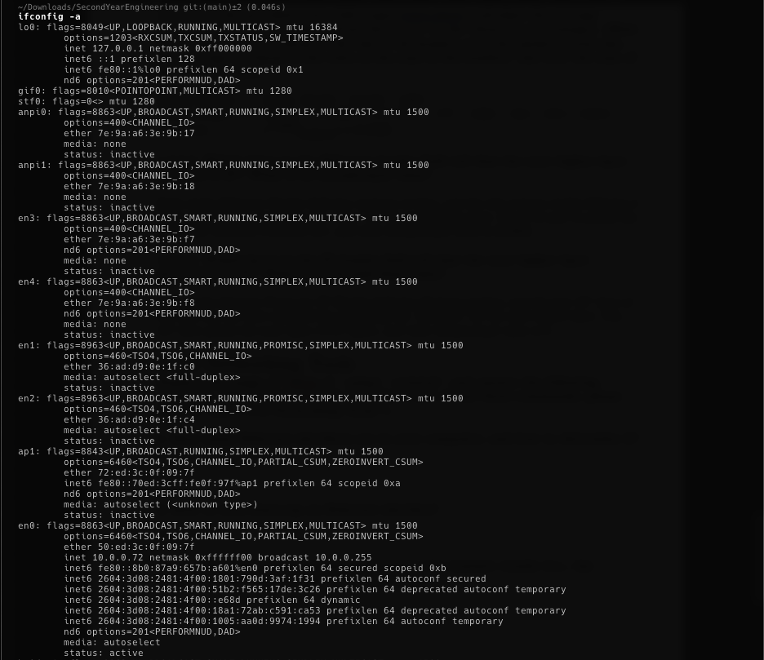

2. How to turn down/up an Ethernet interface?

To deactivate or "turn down" an Ethernet interface, we can use the command sudo ifconfig enX down, replacing enX with the specific interface name we want to deactivate, in our case en0, en1, en2, en3 and en4. The sudo command is necessary to gain administrative privileges required for network interface configuration. For example: sudo ifconfig en0 down effectively disables the Ethernet interface 0, terminating its network communication capabilities.

Conversely, to activate or "turn up" an Ethernet interface and restore its functionality, you use the command sudo ifconfig enX up replacing enX with the specific interface name we want to deactivate, in our case en0, en1, en2, en3 and en4. For example: sudo ifconfig en3 up effectively enables the Ethernet interface 3, reactivating its network communication capabilities.

3. Ping 10 packets to two websites. Compare the statistic results (i.e., the
packet loss rate and average round-trip time).

Let’s ping two websites: www.google.ca and www.canada.ca.

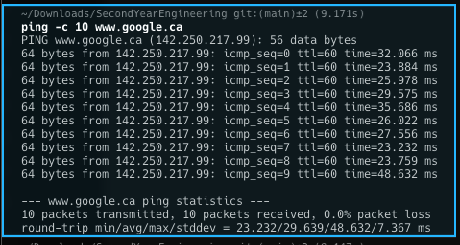

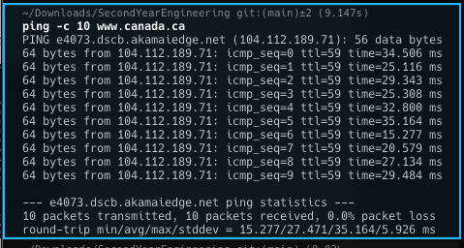

None of the websites had any packet losses, which means that all 10 packets were sent and 10 received packets were also received from each web-domains. When pinging Google, the round-trip times range from 23.232 to 48.632 milliseconds, with an average of 29.639 milliseconds and a standard deviation of 7.367 milliseconds. Conversely, when pinging Government of Canada, the round-trip times range from 15.277 to 35.164 milliseconds, with an average of 27.471 milliseconds and a standard deviation of 5.926 milliseconds.

Average Round-Trip Time (RTT): The average RTT for pinging www.google.ca is 29.639 milliseconds, while the average RTT for pinging www.canada.ca is 27.471 milliseconds. Therefore, on average, pinging www.canada.ca has a slightly lower RTT compared to www.google.ca.

In summary, both websites demonstrate stable network connections with no packet loss observed during the 10-packet ping tests. However, www.canada.ca generally exhibits a slightly lower average round-trip time compared to www.google.ca.

Conclusion
In conclusion, this lab provided students with valuable hands-on experience in capturing and analyzing HTTP GET packets using Wireshark. By engaging with the tool, students gained familiarity with packet transmission processes between sources and destinations in computer networks. Moreover, they explored essential commands such as wget and ping, enabling them to manage ethernet connections and send packets to websites using only Command Line Interface (CLI). The practical exercises helped students acquired foundational knowledge of Computer Network Packets as well as the functionality of Wireshark and its applications in capturing diverse packets across networks. This lab serves as a fundamental introduction to network packet analysis, empowering students to understand and utilize Wireshark effectively in their future lab works in this course.

Reference

[1] Wikipedia Contributors, “Transport Layer Security,” Wikipedia, Mar. 26, 2019. https://en.wikipedia.org/wiki/Transport_Layer_Security (accessed Feb. 08, 2024).

[2] Wikipedia Contributors, “Transmission Control Protocol,” Wikipedia, Mar. 15, 2019. https://en.wikipedia.org/wiki/Transmission_Control_Protocol (accessed Feb. 08, 2024).

[3] Wikipedia Contributors, “User Datagram Protocol,” Wikipedia, Oct. 02, 2019. https://en.wikipedia.org/wiki/User_Datagram_Protocol (accessed Feb. 08, 2024).

